Create IBM Watson IoT Platform And Device

|  |  |
| --- | --- |
| TEAM ID | PNT2022TMID43251 |
| PROJECT NAME | Smart Waste Management System for Metropolitan Cities |

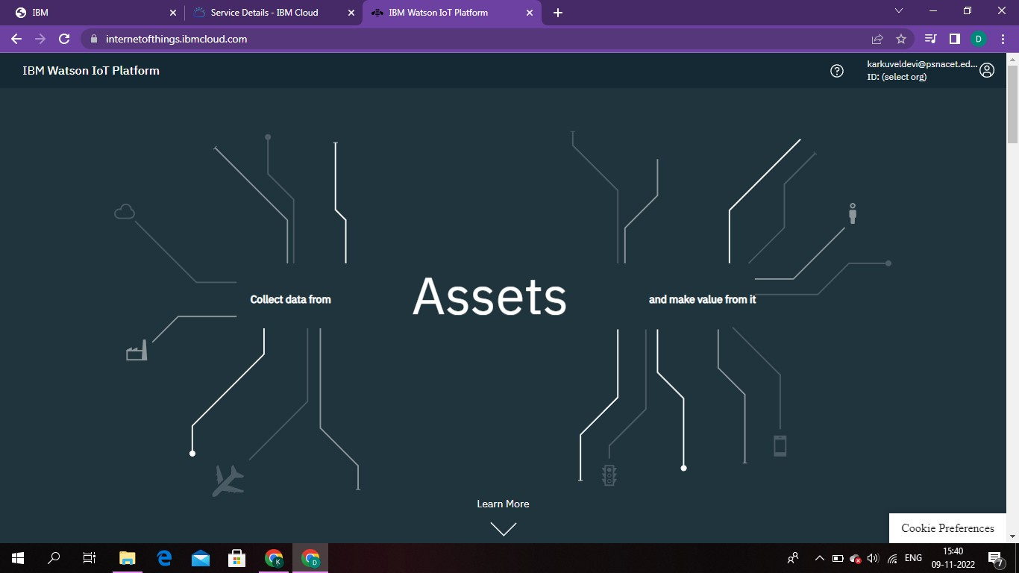

Device

